AT&T- 

Northrop Grumman- 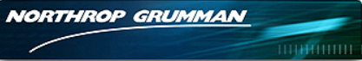

CSRA-

VanDyke is now wholly owned subsidiary of Jacobs Engineering Group 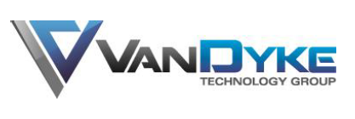 

Mantech- 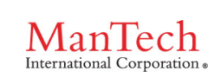

Maryland State Police- 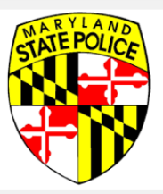

IntelliGenesis, Inc. - 

SW Complete, Inc. 